

**QUOTATION**

217, Sheik Rasheed Building, Hor Al Anz East, Dubai

[www.verbat.com](http://www.verbat.com) | [uae@verbat.com](mailto:uae@verbat.com)

Tel: 00971 4 2973236

|  |  |  |  |
| --- | --- | --- | --- |
| **Renee Media Group (RMG) FZ LLC**  Nitasha Sadhwani  CEO  20A, Floor 2, Bldg 2 (CNN), PO Box 72280  Dubai Media City  055 824 6291 | | | |
| Quotation Date | Quotation No. | Contact Person | Contact No. |
| **Q/WAD/04072016/1299/1**  **04 July 2017** |  | **Ms. Lekshmi Krishna** | **04-2973236** |

**Effort & Timeline for Application Development**

|  |  |  |
| --- | --- | --- |
| **No** | **Development** | **Effort (Man Days)** |
| 1 | Design & Development of Responsive Web Application | 78 |
| 2 | Design & Development of Hybrid Mobile Application | 42 |
| 3 | Design & Development of Native IOS Application | 55 |
| 4 | Design & Development of Native Android Application | 46 |

Note:

1. The above effort has been derived or concluded from the information transferred during an initial requirement analysis meeting and tele-conversation. The above effort and time may change after the detailed system study and the complexity of the modules.
2. The above estimate does not include hosting and deployment charges

**Delivery Time line:**

|  |  |  |
| --- | --- | --- |
| **No** | **Development** | **Effort (Man Days)** |
| 1 | Responsive Web Application + Hybrid Mobile Application* | 83 |
| 2 | Responsive Web Application + Native Mobile Application (IOS + Android) | 95 |

*Hybrid Application performance is generally slower than native mobile applications

**Effort Break up for Server set up & configuration, Deployment and Data upload**

|  |  |  |
| --- | --- | --- |
| **No** | **Server Set up, Deployment and Data Upload** | **Indicative Hours** |
| A | Server set up and configuration with specification as below   1. LAMP (Server, Apache, NoSql-Mongo DB, PHP 5.6) 2. Memcache 3. Ram : 16 GB or greater 4. Core : 8 5. HDD : 125 GB 6. Root credentials 7. FTP 8. PHPMyadmin | 12 Hours |
| B | Deployment | 8 Hours |
|  |  |  |

Note:

1. The rate per man-hour is based on the support mode confirmed by the client which is direct interaction by the client (RMG) with the Verbat Server Team in India.
2. In the event the client is contracting Verbat only for item numbers B, client needs to provide the server with specifications as recommended by Verbat under item number A
3. The above effort includes one-time efforts i.e. Single server set up & configuration, single deployment and one time data upload
4. Minimum payable hours: 8 man-hours.
5. Please note that the above estimated hours is only an indication based on our initial analysis. However it can vary based on the data size and the application complexity. On completion of the above listed task, the exact hours utilized for sever configuration, deployment and data upload along with the total amount to be paid will be communicated to the client.

**THE SOLUTION**

After the initial analysis of the requirements provided by Renee Media Group (RMG) FZ LLC, (hereafter referred as Client), Verbanet Technologies LLC (hereafter referred as Verbat) proposes to create a web based self-serve portal that provides access to various types of reports . The application would be similar to report linker Application (Developed earlier by Verbat for client) having similar infrastructure and outputs.

The Self-Serve Portal will be a Reports Repository that subscriber can access as per their requirements. It will have the following functions

* Reports library
* Instant Reports as per pre-defined Filter Definitions
* Report Delivery upon payment (online)

Verbat will develop the API to access the data for the reports based on information provided by the client

Application Dashboard will have the following Features

* Automated Dashboard with Data Integration (API)
* Data Manipulation : Clean-up, Grouping and Analysis before dashboard stage
* Instant Reports Delivery by email in pdf format
* Sample Reports for user to preview before ordering
* User Management Module for Admin
  + User registration and approvals
  + Storing User Data
  + Email integrations - User registrations, Reports Delivery
  + Handling Custom Reports Requirements
* Online Access (Cloud Hosting of the Application)
* Online Payment Mechanism as per Rate Card - for login members as well as Guest

## User Cases

#### Application Users

* Login
  + Can directly buy reports (one time, login not mandatory)
* Report Selection
  + View details of reports offered
  + Customize reports by filtering for data segmentation
  + Preview report data for confirmation
* Payment Options
  + Payment for selected report (based on frequency or one time use)
  + Report delivery confirmation

## Admin

* User Details
  + View user details
  + Email alerts
* Rate Card & E-Payment
  + Modular Rate Card (Frequency and Usage)
  + E-Payment link with Reports and Rate Card
* API for accessing Data
  + Will be on Real Time Basis (as per User Requirement)

# Sample Application Screens

## Welcome Screen

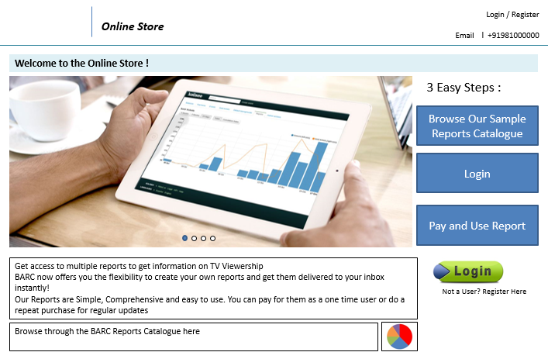

## View Sample Reports

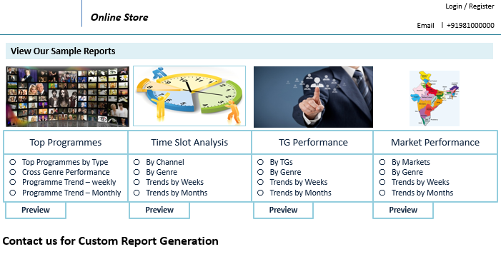

## Buy Template Reports

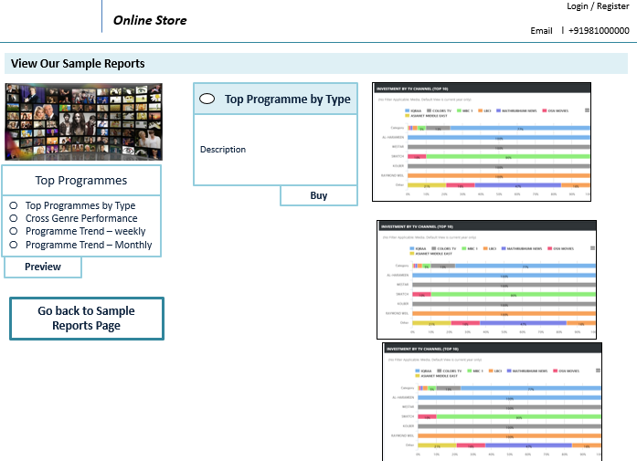

## Create Custom reports with filters

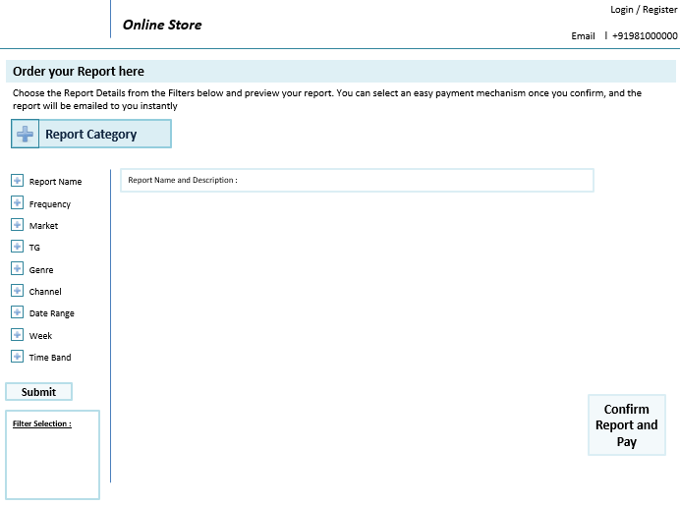

## Create Frequency for report generation

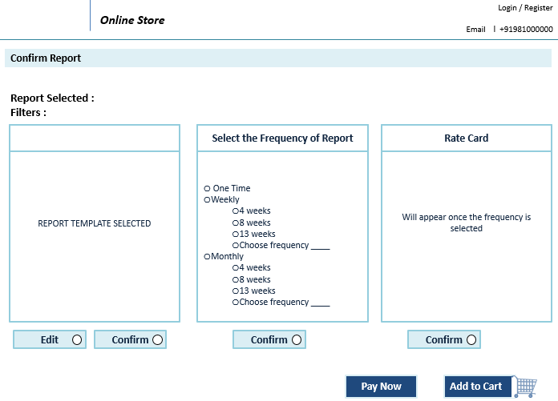

## Payment Options and transaction completion

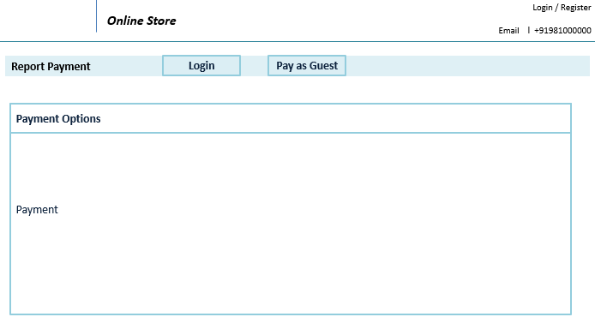

## Application Workflow

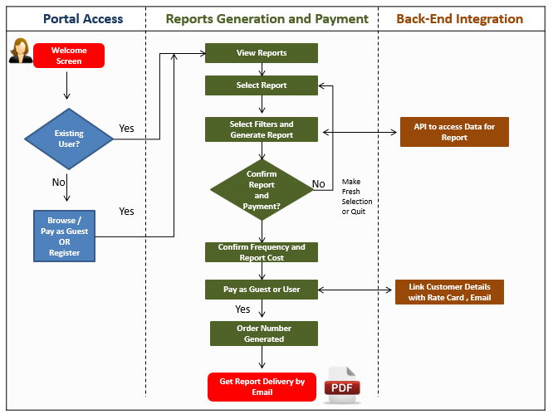

**THE PROJECT SCOPE**

* Design Prototype/Wireframe
* Developing the application in PHP 5.6 and Codeigniter3 with NoSql database
* Testing & Bug Fixing
* Code Release to the client
* One batch of data upload as part of UAT Acceptance (Refer “Acceptance Criteria” clause)

**OUT OF SCOPE**

* Content /image procurement or uploading or editing
* Manual data entry/Migration of the existing data
* Development of the application in any other language other than English
* Deployment and Hosting
* Tablet devices for IOS and Android
* Landscape mode for mobile devices

**Technical Configuration & Server Specifications**

Recommended Hosting Requirement

Web servers should feature a combination of the following software

* Operating System: Linux / CentOS
* Apache
* NoSql
* PHP - Codeigniter 3
* SMTP details for sending mail
* Memcache, GZip, Zip, GD
* FTP
* Disk Space – 120 GB
* Monthly Bandwidth 200 GB

The specification mentioned above is the minimum specification required with features as mentioned.

**Android Device Requirement:**

* OS Version **:** Devices that support Android Kitkat and above.
* Devices : Only mobiles

**Apple IOS Device Requirement:**

* **OS version:** IOS 8 and above
* **Devices:** IPhone 5S and later mobile devices

**Technical Guidelines:**

The guidelines provide instructions and conditions that will be adhered to during the development of the mobile application

* API’s (provided by the client) will be used, as the case may be in realizing the features and functionality mentioned in case if required.
* The client will finalize the functional requirements and wireframe before the commencement of the project
* Verbat will be testing the app in the mentioned devices only. Testing on devices other than the ones mentioned under the “Technical Standards “will have to be specified and provided by the client at the beginning of the development phase
* The client will have to provide the details of the testing devices they are using before the start of development phase
* Client should provide the relevant Developer's Account credentials before the development phase. In case Verbat needs to create the developer id additional charges will be incurred by the client
* The duration mentioned in the project time line is for development and testing and any delay or time taken by the review team to respond will not be Verbat’s responsibility
* Any clarification required from client needs to be addressed within 24 hrs.
* The apps will be developed / created within the guidelines of Apple and Android. Verbat will strictly follow the guidelines provided by the respective stores. Verbat will inform the client if the any of the client requirements/ request deviates from it.
* Customization of the features of the app will be susceptible to the limitation imposed by the respective platform/ store.
* Once development commences the test device/screen sizes will not be susceptible to change. Any change requested by the client will have to go through change management
* OS version support will be limited to the ones mentioned in the technical specifications. Further support will have to go through change management

**ASSUMPTIONS**

The project solution and technology is created from the initial understanding of the requirement shared with Verbat through mail, telephone and in the meetings. The proposed solution is based on the following assumptions;

Objective:

* The requirement is to develop a web based application based on the features mentioned in ‘ The Solution’

Design:

* Client to provide Verbat with the branding guidelines
* The proposed application will be developed in English language only
* Verbat is free to use custom made template for design
* Client shall provide licensed images and logos in specified size & format
* Color theme shall be provided by the client
* Client shall provide the text and associated images for English language

Development:

* Requirements should be well defined, agreed and signed-off by the client
* Internet connectivity is required for the functioning of the Mobile App
* Application and data backups are subject to the purchase of such services at an extra effort
* Client will host and manage the application on infrastructure recommended by Verbat for managing database and application backup
* Mobile Application elements or design cannot be modified once the app is deployed
* This estimate is only for portrait orientation on mobile phones (Not Tabs)
* Supporting OS:
* Android SDK V 19 (KitKat) and above
* IOS 8.0 and above
* Does not support offline access or operations
* Application will not support form level changes in mobile devices
* Client should procure SMS/Email/Payment gateway services, if applicable
* The content for the mobile app will be updated via the application CMS.
* The system assumes that the server where the application would be hosted will have internet connectivity.

**OUT OF SCOPE**

* Migration of the existing data
* Development of the application in any other language other than English
* Deployment and Hosting
* Purchase of images, fonts
* Adding new features to the application other than mentioned in this proposal
* Any other Integration other than specified in this quotation
* Manual data entry
* Detailed Audit Trail
* Database migration
* Data Replication
* Backup solution and Disaster recovery.
* Content writing
* Content or image procurement or uploading or editing
* Annual Maintenance Contract (Bug fixing, debugging) – Please refer section titled “Maintenance and Support”.
* Physical deployment at client’s site (onsite deployment)
* Hosting Infrastructure and Maintenance (web and email hosting)
* Hardware Integrations / procurement and purchase
* OS other than mentioned in the assumptions
* Mobile offline access or operations

**DELIVERABLES**

* Design Prototype/Wireframe
* Developing the application in PHP 5.6 and Codeigniter3 with NoSql database, Android Studio and XCode
* Fully Developed & Tested Application
* Code Release to the client

**ESTIMATED DELIVERY TIMELINE**

|  |  |  |
| --- | --- | --- |
| **No** | **Development** | **Effort (Man Days)** |
| 1 | Responsive Web Application + Hybrid Mobile Application* | 83 |
| 2 | Responsive Web Application + Native Mobile Application (IOS + Android) | 95 |

*Hybrid Application performance is generally slower than native mobile applications

Ten (10) UAE working days for prototype from the date of LPO/Signed proposal with advance payment and between Seventy-Three (73) to Eighty-Five (85) UAE Working days for the development of the application from the Date of Approval of the Prototype

* The above-mentioned timeline is in UAE Working Days
* The timeline mentioned for prototype is after the receipt of LPO & Advance payment
* The timeline mentioned for development is after the confirmation of the prototype from the client.
* Any delay in getting the approvals of deliverables from client will cause change in timelines and the revised timelines will be updated in weekly status reports shared with client after the project commencement
* All approvals and queries regarding the client requirement and any queries which may hinder the project advancement at any stage should be answered by the client within 24 hours from the time of initiation, failing which the time delay will get added to the actual effort and timeline which was estimated.

**DEPLOYMENT**

* Client can opt for hosting the proposed application at Verbat’s Server.
* If deployment is at the client server, responsibility of deploying the delivered built onto the production environment after conducting the necessary acceptance testing will lie with the client unless and until requested for Verbat’s support for deployment.

*Note: Deploying the application at the client server will also call in for additional effort.*

**Change Management**

Any addition which comes out of the project scope, upon and after the launch of the application will be considered as change management. Verbat recommends the following change management procedure for the same.

* Any change which comes out of the project scope, which was discussed, documented and mutually approved by both the parties in the requirement stage, will be carried out only through raising a change request.
* Change request will be studied and an impact analysis on the existing work flow will be performed.
* On finalizing the impact, effort estimation for the change will be calculated and raised as additional requirement.
* Verbat will initiate the change request only after getting a formal approval from the client for the additional changes raised.
* Any change from the scope will be charged at per man day effort and approval from the clients will be availed before commencing on any change management.

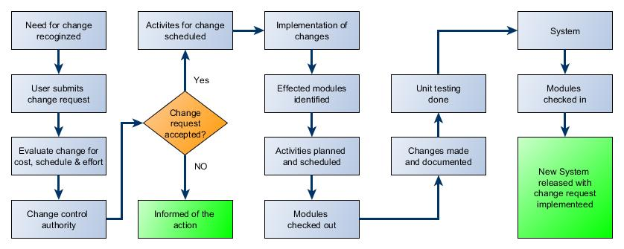

**Acceptance Criteria**

* Client shall test the application for the acceptance of the project.
* The UAT and UAT sign-off should happen within Fourteen (14) days from the date of completion of the project from Verbat’s side and its release to the client (UAT).
* Upon acceptance, client will provide a written statement of acceptance.
* In case the user acceptance testing is not completed by client within the specified time period, the product will be deemed as accepted.
* Any comments or reason for rejection need to be documented and the same needs to be sent as an email from the official mail id of client to Verbat.

**General Terms and Conditions**

* Offer Valid for 30 calendar days from the date of submission of the Proposal
* An average of 20 working days are assumed in a month
* All the projects activities will be carried out from our off-shore development center in India
* All the documentation will be provided in English.
* Third party components may be used to develop the application
* After the project initiation, any delay in the delivery timeline due to the non-availability of data/ confirmation from the client shall be updated in the weekly status report , hence needs to be considered as the actual delivery timeline
* The scope of the project is limited to the design and development of features understood and mentioned in this document. Any changes or additions will have to go through change management
* This proposal and all technical/ functional specifications have been derived or concluded from the data shared via email / information's transferred during the initial requirement analysis meetings and conversations. Verbat reserves the right to amend the terms of this proposal, should the SOW terms, functional features and functionalities change during the course of the project
* During the requirement gathering phase, authorized personnel from the client’s side is expected to be available for discussion and finalizing the HLD (High Level Design), before development commences
* The applications will be built as per the specifications agreed mutually. Any changes will be executed through a deﬁned change management process between both parties
* Acceptance criteria shall be based on the clauses which were mutually discussed between Verbat and client at the Requirement Analysis phase and the same will be documented and approved by both parties through official emails
* In case Client requires any extension of the proposed acceptance schedule, the associated effort and effort of such extension can be mutually reviewed.
* For any circumstances if project needs to be put on Hold / Stop it requires minimum request notice period of 1 week along with duration for which request will be addressed by management and final decision on the request will be based on that.
* If deployment is done in client’s server, Verbat cannot be held responsible for any performance issues arising due to hardware malfunctions.
* Client will provide all the necessary contents, both text and image, before starting the project in the format suggested by Verbat.
* All Source code and other project artifacts would adhere to the Verbat document templates and internal coding standards
* Client should provide the relevant information, data and hosting environment well in time for the execution of a related activity. Non- availability of this information or data may lead to an interruption of work which may result in a delay in delivery as well as additional efforts to the client
* Client should provide the required server space according to the technical specifications as suggested by Verbat for the proposed application
* Payments due from client to Verbat should not be held back due to the non-availability of server
* Since the application will be hosted on the client server, Verbat cannot be held responsible for any performance issues arising due to server malfunctions.
* Client is responsible for data backup in case the application is not hosted on Verbat server.
* Source code will only be delivered once the due payments are made.

**Source Code & Intellectual Property Rights**

* Upon completion of the Project and 100% completion of the payment, client will have access to the source code except for propriety codes, developer tools and third-party application / modules like Microsoft Dynamics Products, Share Point LMS etc.
* The solution offered will be the intellectual property of the client and will be made available to the client on an “unlimited license” basis.
* Modifications by third party/person: No person or organization, other than Verbat or any person authorized by Verbat in writing, has any permission to modify/change the software Solution to be eligible to get continued support from Verbat as per the support terms defined under this document.
* Liabilities/Damages: Verbat accepts no liability or damages of any kind arising out of use or non-use of the software delivered. The responsibility of testing of software lies with Client.

**Maintenance and Support**

* Maintenance contracts by default are supported as per the basic SLA terms.
* AMC with Basic SLA is charged at 25 % of the total project value. Additional Effort/change management request will be added towards Total Value of the Project to determine the AMC value.
* Maintenance support is limited to providing application support for ensuring the consistency of the look-and-feel, bug fixes and user issues i.e. maintenance and support of the existing features of the application.
* Support does not in any way cover providing technical or other support to the end users. The maintenance agreement does not include functionality changes or feature additions which are handled as change requests which will be charged per man day. AMC does not include server support, maintenance and application deployment.
* AMC charges will cover Off-Site Support and Debugging. Support includes E-mail, Telephone and Chat unless explicitly specified. In the event, the application is hosted with the client; necessary remote desktop connectivity should be provided for carrying out maintenance activity.
* Gap in AMC - In case if the client does not opt an AMC for a year and want to renew it after that period, 50% of the AMC amount for the year for which AMC is not taken will also be payable if the client wishes to renew the AMC contract.
* Note:
  + Please note that the AMC support shall start only after all the necessary sign-offs (AMC Document) to this effect have been given.
  + It is not mandatory that the client should opt for an AMC. The client will still be supported on an ad-hoc basis on an agreed man-day rate.
  + AMC Payment Terms: 100% to be paid as advance.

**Service Level Agreement**

|  |  |  |  |
| --- | --- | --- | --- |
| Key | Max Response Time | Max Resolution Time | Target |
| Basic | 1  working day | 3 working days | Request / incident / problem tickets |
| Advanced | 5 Business Hours | 12 Business Hours | Request / incident / problem tickets |
| Priority | 3 Business Hours | 5 Business Hours | Request / incident / problem tickets |

Note:-

* We provide Basic SLA as standard with AMC while Advanced and Priority SLAs attract additional charges.
* Time zone applicable as per India time zones (3:30 AM GMT to 12:30 PM GMT- Monday to Friday).

**Few Mobile Application References**

**Carrefour: SaadaConnect**

* Mobile app for understanding employee’s engagement that delivers valid and actionable insights
* True Engagement - When survey questions are based on psychological conditions of engagement rather than promotional perks, you can uncover where real pain is being felt, pinpointing the department, team, or roles where action is needed
* Less Time Administering, More Time Engaging
* Clear, Reliable Insights
* Share company related news, videos directly to all employees and get their feedback & comments

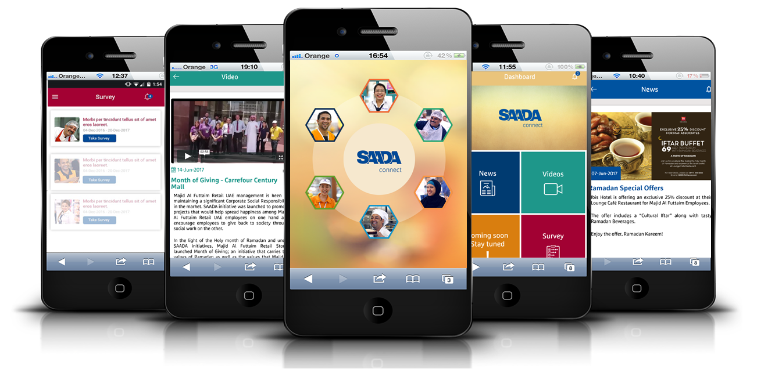

**Carrefour: Pick Pack Delivery Application**

* Client planned to initiate an online Grocery shop and wanted a system to   
  help them fulfill this initiative.
* The system streamlines the pick, pack and delivery
* Pull order list from existing application
* Manage order list
* Allocation of orders to handheld/pickers/ master pickers
* Verification & approval of orders picked and security check
* Scanning and storage of the orders
* Manage delivery

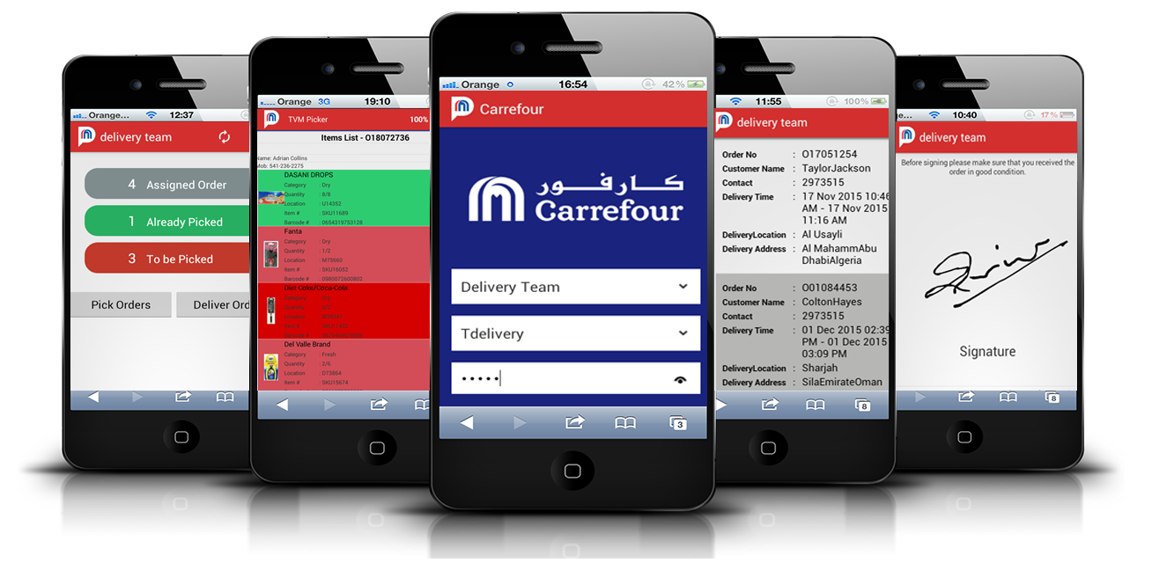

**Our Few Clients**

